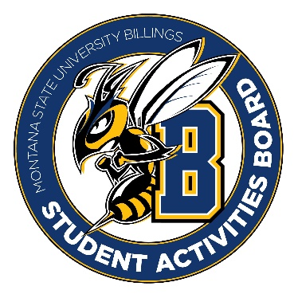

Student Activities Board

General Meeting
  - Meeting Summary

Date/Time of Meeting | Date: 03/09/2026 Time: 6:00
Location of Meeting | SAB room
Members Present | Kaelyn, Taylor, Thomas, Kennedy, Alia, Izabella, Aspen, Chloe
Members Absent
Guests
Minutes Issued | 6:00-6:25

  - ANNOUNCEMENTS:
- Everyone needs to fill out the leadership award nomination form by tonight!! We want everyone to fill this out so that we can have dinner together!
- Start spreading the word that SAB is looking for new members, both general members and executive members.
Open Mic Night RECAP:
- We think that there were at least 30 people who popped in and out throughout the event.
- Maybe we can try hosting the event in the SUB Atrium instead of the theater to see if we can get more students.
Pros:
- Having it an open night seemed to have brought in lots of new students.
- Overall, we felt it went better than just regular karaoke.
Cons:
- There were a lot of technical issues. We need to show up earlier and be set-up and test everything before the event starts.

Next Event
Event Name | Discussion
- Craft Night  - Tuesday 10th from 6-8  - We need to be there at 5:30 | - We will have diamond paintings, color pages, and friendship bracelets.  - There will be snacks and drinks provided as well.
- City College Crafts  - Wednesday from 11-1  - Be there around 10:45 | - We will bring the leftover crafts from craft night to this event.  - We need to also do recruiting at this event to try to get more people to join SAB.
- Performer Event  - Week of the 23rd | - Possibly Drag Queens  - More to be announced on this event!

Other items talked about:
- Going forward we will give general members a two to three weeks’ notice for general member events as well as provide you with a packet to help you succeed with the event.
- We need to start thinking about the end-of-year events.
- For CRAM JAM we are thinking about just doing BINGO and no Trivia for this event!
- Summer sendoff is coming quickly, and we need to start thinking about ideas you want to see for that. Some examples could be a kick ball tournament or dodge ball tournament. Maybe we have food trucks (snow cone truck, ice cream truck)
- Please try to find some people to join SAB. FYI ALL positions are open for SAB, if you want to be an executive member, fill out the form!
- We are looking to create a new executive position that is dedicated to someone who can focus on city college events. This individual will be the one in charge of coming up with events for city college and running those events. It is preferred that this individual attends city college and knows what works best there.

