Results of Spring 2019 Hyflex Student Survey
N=61 (3 classes: BGEN 105, COMX 435/525, SOCI 482)
Q1: Please describe the format in which you primarily participated in the class (primarily online, on campus or both.)
Primarily online: 31 (51%)
Primarily on campus: 11 (18%)
Both: 19 (31%)

Q2: What factors affected your decision to engage in the class in the format you described above?

Work/family schedule conflicts meant on-campus attendance wasn’t always possible: n=21
Student learns better in person so preferred on-campus: n=13
Student lives outside of the local region so online was the only option: n=7
Class schedule conflict made online the only option: n=7*
Both because student preferred the combination of delivery methods: n=5
Attending class on campus was convenient: n=3
Online is the students preferred delivery method: n=2
Athletic participation schedule required missing class: n=1
High school schedule prevented on campus attendance: n=1

*This reason was provided only by students enrolled in the City College course.

Q3: Which aspects of the format of this class worked best for you, and why?

The flexibility of being able to participate in class or online: n=35
The option to participate fully online: n=7
The ability to work at your own pace during the week: n=7
The discussion boards were well organized and helpful: n=5
Having class meetings only once a week: n=2
Deadlines that kept students on track: n=2

Representative quotes:

Flexible delivery:

“I liked the way this class functioned this semester. Meeting both in class and online helped me understand the topics better and be more engaged on the subject during class.”

“I enjoyed having the option to participate online or onsite. I am a part of the baseball team and there were 4 times this semester that I was out of town and couldn’t attend the Monday night class. So, having the option to participate solely online for those specific times helped me out a lot so I wouldn’t lose points or information from that day.”

“I loved that I was able to do all of my assignments online and how I could attend class online or in person. It gave me a bit of stress relief knowing if I couldn’t make it to class in person, I could just participate online.”

Fully online participation:

“I really liked having the option to do a discussion post or come to class. Unfortunately I had a class at the same time, so I wasn’t able to attend actual class.”

“I appreciated that the options for participating in class or online were presented every week. While I was unable to participate in class, I liked knowing what the in-class students were doing that week and how my participation compared with their experience. I had hoped to be able to pop in to a class at some point in the semester, but it never worked out.”

Q4: Which aspects of the format of this class did not work well for you, and why?

Nothing. It worked great: n=23
Getting confused by the schedule: n=14
The organization of the class: n=4
Did not like doing assignments online: n=3
Fear that online will replace face-to-face education: n=2
Computer technology problems: n=2

Representative quotes:

“I really didn’t like two separate platforms. It made it kind of difficult to know what the due dates were and to make sure I was doing everything required of me.”

“The class ran Thursday-Monday and it was confusing to remember when assignments were due. The rest of the university classes run Monday-Sunday or something more to that effect. The set-up just threw me off a bit.”

“I’d say it was just a scheduling issue with myself. I forgot stuff. It was just poor planning.”

Q5: If offered, how likely would you be to take another Hyflex class? Please explain your answer.

Very likely: 39 (64%)
Likely: 19 (31%)
Unsure: 3 (5%)
Unlikely: 0 (0%)
Very unlikely: 0 (0%)

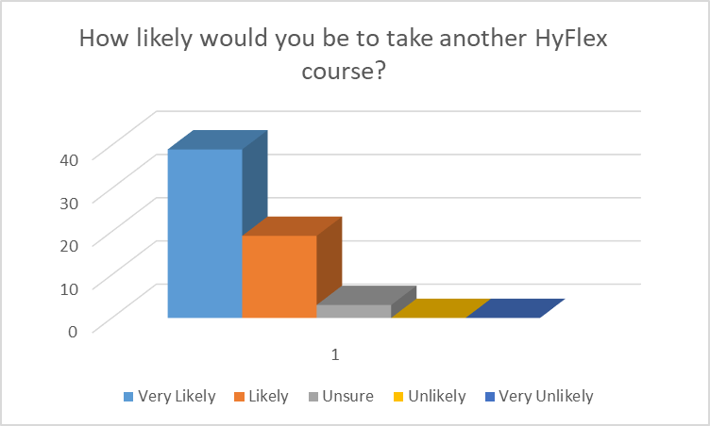

In sum, a full 95 percent of respondents said that they would be likely to take another HyFlex course if it was offered.

Representative Quotes:

“I would take a HyFlex option 10/10 times. It is especially helpful for times when the unexpected happens and you are unable to make it to class. This format of class is very relevant for college students, considering how many other things most of us have going on in our lives.”

“VERY likely. I think it’s a great opportunity to have the best of both worlds. I will look for these types of classes in the future to meet the students and the teachers when I can and then be online when that is my only option. I also travel so this is a perfect solution. Been an awesome ride!”

“Very likely. This format works perfectly for non-traditional students who have work and other outside responsibilities. I have always liked online classes because of their flexibility. A Hyflex class provides convenience while also allowing students to better understand the material through in-class discussion.”

Other helpful comments:

“…I have 24 credits to finish and would love to see this format offered for every class. It is the best of both worlds in one course, giving the student the ability to choose weekly what works for them. I would like to note, however, I am very fortunate that I can be organized and disciplined enough to do well at taking online classes. It may prove difficult for kids leaving home and facing great responsibility for the first time. Perhaps offering some sort of seminar or prep course on how best to get organized and take online courses would be a good idea if the university is looking at this being the main course format being offered in the future.”

“I have mentioned that I have my concerns for the new technique, however I certainly see the benefit and enjoy the freedom of choice. Again, I just hope it does not lead to in-person instruction becoming a cost-cutting method of the past. I believe the “live” experience is very important. That being said, I would have no problem enlisting in this format again. JUST DON’T GET CARRIED AWAY WITH IT!!!”

