PROFESSIONAL:
Why have I been successful with my Fulbright applications? Two main reasons: I do a lot of research to find organizations/universities that share my professional interests (integrating and preserving culture through English language learning; this field of study is rather unique) and I apply to more remote locations or countries. While it is still very competitive, there must be fewer applications for these countries. I get on to the country’s university websites, find out the professors’ names, look into their research to find similar interests, and then email them if see if their university might be interested in sponsoring me. If you can, submit a letter of invitation with your application, but I didn’t have an official letter from Chile until after the application deadline so I just included the email that indicated they would be writing one and when it arrived, I sent it in later.
The University of Prešov, with a student enrollment of approximately 10,000 students, is located in eastern Slovakia. Although Prešov is the third largest city in Slovakia, its population is the same as Billings (around 100,000). In square mileage, six Slovakias could fit into one Montana! It is in a great central location for travel around eastern Europe.
I wasn’t informed of my specific responsibilities until after I arrived. Another colleague going to Slovakia did not know her schedule yet either and the Fulbright Commission Director wrote that this is not unusual (professors get back to work in mid-August from the summer break and do their planning then). However, had I known months earlier, I could have planned better for what educational materials I would have brought as well as have time to work with my co-teacher.
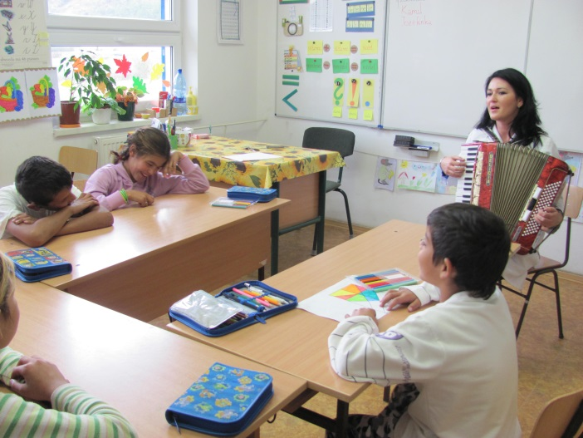
(This picture is a Roma special education class)
I will be co-teaching three courses (English Communication I for freshman, Communication III for seniors, and Pedagogy for Practicing Teachers) with one of the instructors here. Not sure if all courses are like this, but he didn’t have a syllabus nor teaching plan. He walks into the classroom and uses a workbook that he has scanned for students to see (students don’t buy books; not sure AT ALL about the copyright laws here, if any, since instructors appear to scan whatever they need). We haven’t finalized my role yet, but as a native English speaker I suspect my primary role will be working on English listening and speaking with Dr. Kresila teaching reading and writing. My classes range from 11-24 students. All classrooms are equipped with computer, projector, screen, and internet access. Students are respectful and of course, hesitant to respond to my questions as I am so new and because the system here is very traditional (lecturing, note-taking, and exams). I will probably start taking them out in small groups, pairs and individually to better accomplish my goal of improving their speaking and listening.
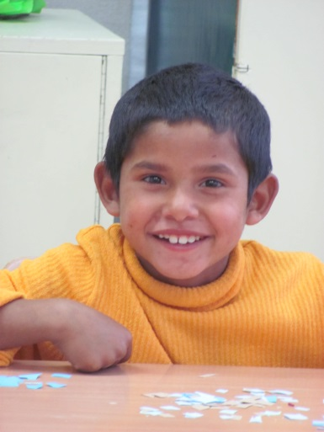
MSUB has a collaborating relationship (they have sent four students to MSUB) with a local high school in Bratislava, capital of Slovakia, located right across the Danube River from Vienna, Austria. Since I had a Fulbright orientation in Bratislava, I came a few days early so I could visit the high school and investigate the possibility of sending MSUB students there to do their student teaching and present the opportunity for their students to take MSUB general education courses online. Since education is free here, and international students would pay our out-of-state tuition, there really isn’t a market here for online learning. However, after my school visitation, it appears this would be an ideal school for our student teachers of English if they wanted a unique and interesting experience. Classes I observed were interactive with good critical thinking discussions. Talk with COE if you are interested…an opportunity of a lifetime!
NOV-My classes are going well. I find out what Dr. Kresila is teaching that day and try to relate it to my lesson (I try to bring in cultures from around the world into the lesson). I take students out in small groups from the main class for about 15-20 minutes each and emphasize listening (to me) and speaking (each student must participate to some degree). This month I’ll start to take them out in pairs and then next month individually.
I have made two presentations to the faculty and students (one on U.S. Education and another on U.S. Teacher Education) and have another presentation this week on the ACTFL Proficiency Guidelines. I am scheduled to visit the British and American Studies department classes this month. I presented at the Innovations in Education 2013 conference in northern Slovakia (national elementary teachers’ conference) last month.
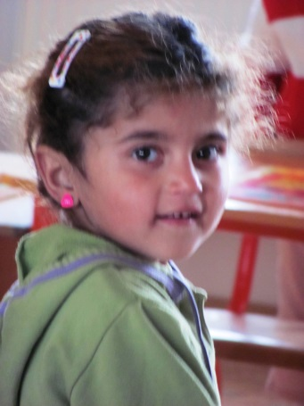
I have made several visits to local Roma schools and am talking with many about the dismal educational issues with the Roma culture. For the most part, they are segregated into either schools of their own or their own classes if the school has them at all. Efforts to integrate them into Slovak schools/classrooms have not been successful; in fact, when a Director (principal) has tried to integrate classrooms, Slovak parents will remove their children from the classroom and send them to another school, even if it’s in the neighboring village. The loss of student numbers significantly affects the schools’ finances and thus, Directors won’t integrate for this reason (among many reasons). Roma live separately in “pockets” in larger cities, or actually outside of villages in housing that would be considered sub-standard . Roma have the highest rate of employment in Slovakia and the Slovaks resent the fact that their taxes are paying for their unemployment and social services. Some Roma children come to first grade speaking only Roma and have very limited previous experiences in Slovak life and culture (they have very large families; another contention with Slovaks since they collect benefits by the number in the family). Although kindergarten (ages 3-5) is available to the Roma, they choose not to participate, for the most part, and keep their children home with them until the mandatory first grade. Roma teenagers marry early and start families soon thereafter.
In order to learn more about this culture outside of Slovakia, I was able to visit the Institute of Ethnic Studies in Slovenia (not to be confused with Slovakia; two different countries). I also visited a Roma community, kindergarten and after-school program which seemed to be helping Roma students perform better in schools, although they were still segregated. The kindergarten had a Roma teaching assistant which appeared to be a super way to start some integration. I head to Hungary at the end of this month to teach a lesson to some Roma students and will get another perspective about this fascinating culture. In January I’ll visit with Roma students and visit a school in northwest Turkey.
DEC: As MSUB students in the U.S. are finishing their fall semester within the next weeks, I’m trying to wrap up my teaching here as well. Finals are very different; finals can run from Dec. 23rd until the first week in February. There is no official final schedule, and students have two more chances after the first one to successfully take their final. Because I am leaving the second week in January, I’m giving my finals the week of Dec. 16-20 so I’ll be available should they need to take the final again in January. Although there isn’t a specific holiday “break” for faculty, I’ve figured out that the two weeks around Christmas everyone will be on “holiday” so that’s when I’ve taking mine as well.
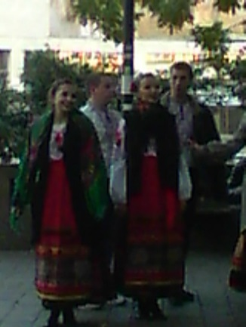
My trip to visit Roma students in Hungary was fascinating. There are practically no Roma students in the college of education in Prešov; Roma students often have difficulty in higher education and those that do succeed, usually do not choose education as their careers. The four Roma university students I met with in Budapest are not going to be teachers, but they are involved in a special project that supports Roma students trying to get their university degrees. They live in a dormitory, receive tutorial support, English lessons, and small living stipends; very similar to the Big Horn Teacher projects MSUB had several years ago. Would love to follow these girls into their professional careers…
One of my projects for this Fulbright is to investigate the possibility of creating a tri-lingual children’s book (English, Slovak, and Roma) on a Roma folktale which could be used in kindergarten and primary classrooms to support diversity and multicultural education. I have found some very respected colleagues to work with me; one has lived among the Roma and written a book about the importance of their identity and the other is a Ph.D. Roma scholar who works with the Ministry of Education. We have selected a folktale and are now finalizing the text. Another colleague has volunteered to be the Illustration Editor and gather pictures from Roma students for the illustrations. Hopefully, the first real draft will be done by March. We have also talked about a short manual to assist teachers in Read-Aloud strategies. There is a Roma folksong that goes along with the tale, but I’m not sure we’ll have the time to really integrate it into our book. I’m looking into funding for a return to Slovakia in 2014.
This was an excellent opportunity for me to pursue professional interests that I normally do not have time to do when in the U.S. I couldn’t have had a better experience and the professional relationships I have formed will continue in the future (I am working with two different colleagues on two different professional articles and of course, will continue on the book).
IF YOU GO:
Prešov does not have a local airport so I booked my flight to the nearest small airport in Košice, Slovakia (KSC) through Vienna (VIE). I spent several months checking prices and determining which flights had the fewest number of stopovers (3 from Billings) and of course prices. Although most of the prices ranged from $2,200 or higher, I found one for $1,400 with Orbitz (and I had several schedule choices). The fastest time was 17 hours (over $6,000) but most the flights were around 26 hours. Most importantly, when I tried to book through Delta or United, they basically stopped in Vienna and I would have had to gather my luggage for the short flight from Vienna to Košice and pay exorbitant luggage fees on Austrian Airlines (my colleague ended up paying over $350 in fees). And, with my Orbitz ticket, my luggage went straight through to Košice! It wasn’t until after I had booked that someone mentioned that it might be cheaper to go through Budapest; I haven’t looked into that.
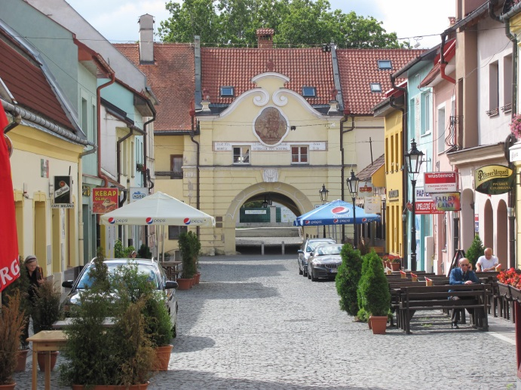
You don’t need a visa to get into Slovakia unless you plan to stay longer than three months but make sure your passport is current for the time you are traveling (and then some, just in case you get stuck somewhere). Since I will be here for over four months, the Fulbright Commission sends in my paperwork for a residency permit. In addition to filling out the application, I needed an FBI clearance (with my birthdate on it) within 90 days of my arrival, as well as a medical clearance which included such tests as HIV and TB in addition to an overall physical.
This photo is of the 15th century Florian gate to the old city, around the block from my flat.
I have an iPhone 4 with Verizon and when I tried to add a Global Plan for Slovakia, found out that my phone will not work in Slovakia. So, I am without a phone until I can purchase a local burner phone when I arrive. Check out your options before you leave. I did read that Verizon works with Telefonia phones…(I’m using Orange since I couldn’t find Telefonia).
I arrived late (after 11 p.m.) at the Kosice airport, so I asked my hotel to pick me up. Make sure they will have a sign for you with your name on it and get the name of the driver if you can. I stayed at the Ambassador Hotel in Košice, right in the old city. The trip from the airport cost me 14 Euros (well worth it!).
NOV – The trains are on time for the most part. There are local trains, ones that go out of the region, and some that are express or Intercity (the fastest but also the most expensive). However, I got a senior pass (over 60) which cuts the cost considerably. You have to fill out a form and must have a permanent local address so it won’t work for most tourists. You can reserve seats on some trains but I have found that the trains haven’t been crowded enough even though I usually reserve since it’s only an extra euro or two.
Check opening times of museums and sites carefully; in fact, I’d have the hotel call them to be sure they are open. For the open air museum in Martin, I took the train, then a taxi (it’s out of town in a pretty rural area) only to find that the museum was closed that day (even though I checked online and the hotel said it would be open). I was SO lucky that the taxi gave me his phone number because there wasn’t any way for me to get back to the train station since it was so far out in the country. Another thing I learned in Bratislava; DON’T hop in a taxi outside the train station. It was 15 euros minimum which is five times the normal rate! You need to call or have someone call for a taxi.
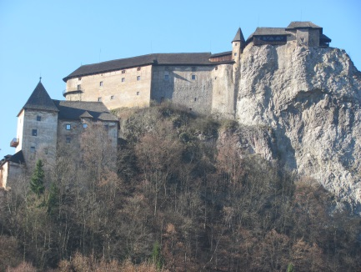
There are lots of castles to hike to or visit…the largest in Central Europe is near Presov: Spissky Hrad. I just visited Oravasky Hrad near the Polish border this weekend. It was the castle used in the first Dracula movie (1922). It is located on top of a rock hill overlooking a river (very dramatic). The rooms are loaded with period furniture and cultural items as well as arms and hunting weapons. I would highly recommend this tour (wish I’d had more time to spend in the museum rooms! Eakle would be happy that the tour was in Slovak so I couldn’t ask a lot of questions!)
DEC: The weather is starting to get cold (not as cold as MT today!) but the days are usually quite clear. The Christmas market (booths set up in the town square) and city decorations are beautiful and we had our first snow last week. If you don’t mind cold weather, this is a perfect month to visit. The ski resorts are all open now. I must admit, though, that it gets dark by 3:30 p.m. so the days are very short in Dec.
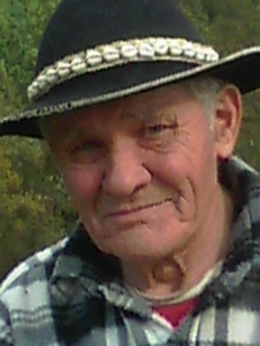
Travel is pretty easy with public transportation. You usually don’t have to get train or bus tickets in advance, although you must plan ahead if you plan to travel early in the morning, late at night, or in smaller villages when the ticket office is closed. The fastest trains (that make fewer stops) are caller IC trains and they require a special ticket. They cost a little more (not much) but save you all sorts of time. If you try to pay on the train without a ticket, it is very expensive (My friend was fined 28 euros when her bus pass expired the day before). On some trains or buses, not local ones, you can reserve seats, but I have found that it really isn’t necessary. It is interesting that life revolves around transportation; for example, one evening in a restaurant, people in our party left at different times to catch different buses home, paying special attention to the “last” bus for that night. Even those that own cars often choose to use public transportation since gas is very expensive.
One advantage to Slovakia is its central location. You can be in another country and culture in a matter of hours which allows you to see much of Central Europe from a central base. I’ve never felt threatened or afraid and it is much less expensive than many other European countries, especially those in the west.
PERSONAL:
I never take anything that is really valuable to me; you never know when your luggage may get lost or get stolen. So, with the exception of my professional suits, I wear clothes that I usually leave at women’s shelters or churches when I return. Most of my luggage weight is educational materials (books, texts, calendars, stickers, games, workbooks, etc.). I always come to the airport with the boxes open at the top so if TSO needs to see what’s inside or they weigh more at the airport than at home, it’s easy and quick to take things out ; I bring strapping tape to then close the box after inspection. I maximize my weight by bringing extra books to the airport just in case! I can’t tell you how much teachers in remote areas or in countries where books are expensive appreciate these. I also bring U.S. chocolate or local huckleberry candy as “thank yous” during my trip as well as children’s books (once helped me get across the Chile/Argentina border without the proper documentation after I had given a border officer a book for her children the week before) and a couple bottles of U.S. wine. Finally, if I have any room, I try to bring some ethnic spices for cooking when inviting locals over for dinner. Not sure, now, I’ll use them here since the food is VERY basic and it doesn’t seem Slovaks like spicey food. I WILL enjoy them, however. The government subsidizes one meal a day so I only pay $1.30 for a full meal (soup, salad, meat, potatoes or rice, etc.). And the portions are large so as is my MO, I take half of it home each day for dinner that night (and spice it up a bit).
I take enough medications to last the four months, including asking my physician for a couple CIPRO pills (great for digestive troubles with foreign food and water); I also bring a portable water purifier (Steripen) just in case. Again, carry these with you. I also travel with several first aid kits.
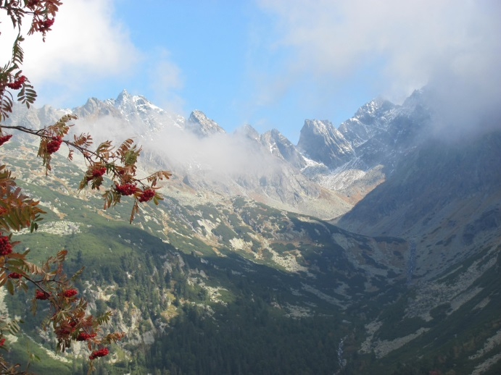
Those of you who know me realize that I hardly ever use my SMARTphone (especially since we don’t get reception at our house in the mountains), but it was really hard for me to travel without a phone. I now have a burner phone that is sometimes in English but messages from the telephone company are in Slovak. I am trading private Slovak lessons for English ones with a Vice-Dean here; she assigned me 20 pages my first week and I gave her a short journal article on language acquisition for next week’s discussion. Who do you think will be up the night before? Slovak has 46 different letters and all kinds of guttural sounds I have yet to master! Thank God for GoogleTranslator…
I have been able to attend several cultural events these first couple of weeks. One was a modern ballet that I think was very “deep” as the dancers had certain Slovak words on their shirts and I could tell the audience was a bit shocked with some of them. It was in a magnificent old theatre and cost me nothing (I have no idea why not, but the lady at the window just handed me the ticket). And I attended a folk music concert last week; the man sitting next to me knew EVERY song and as many in the audience, sang along! People laughed (they had a very funny comedian at least according to the audience’s response), clapped along, and thoroughly enjoyed the performance. My favorite part was when a 3-yr-old came on stage and sang almost a whole song on key! I’m headed to another one in two weeks.
I’ve also been able to bike and hike. Last weekend I biked to a neighboring village along the main river that flows through the city. A colleague took me to the High Tatras (pictured here) this past weekend and I loved getting out in the mountains. I also hiked up to an old castle from the 15th century near Prešov (trying to get as much outdoor activity done before the snow arrives).
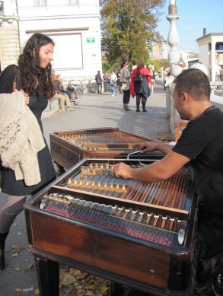
NOV-Several of you have asked how I can leave for four months; when you think of a lifetime it is but a drop in the bucket. The time passes very quickly for me as I am experiencing so many new things and challenges. Being immersed in a culture is the only way to go when really trying to understand other people in our global society. Nothing compares to actually interacting with people from a country. I have so enjoyed hiking several weekends with a colleague, sharing meals with several different people, and I’m now on a co-ed volleyball team (yes, I’m by far the oldest one and so short I’m lousy at the net). I played squash yesterday for the first time; definitely different than racquetball even though the courts are close in size. I’ve met a high school English teacher who loves musical concerts and we’ve gone to several together already. I have hosted two baseball games so far and last Tuesday for our Education Day at the university, they asked me to host a third one as well as a session on Country Western line dancing (yes, I brought a DVD and bandanas with local Carbon County brands on them). Since it rained, no baseball, but the line dancing was really a hit! I had over 50 students who wanted to participate but we didn’t have room for them, even when I did two extra sessions! Go, “Achy, Breaky, Heart!”
I have to share a real cultural story! At the beginning of October I saw some real cool candle lanterns (all shapes and sizes). I bought one and thought it would be great as a centerpiece on my dining table when I had company over for dinner. The first time I used it I knew that it wasn’t for a centerpiece as they were all quite amused. Well, November 1st is All Saints Day, a day when everyone goes to their relatives’ graves, brings flowers, and, you guessed it, lights a candle lantern at the gravesite. That night is the most beautiful evening with all the lanterns and flowers! But, of course, my lantern wasn’t appropriate for a table centerpiece! Ah well, everyone had a good laugh!
DEC: I play volleyball with staff members every Wed. and that has really opened up a lot of social interaction with Slovaks. I went to a UNESCO cultural site (Bardejov) and visited her small village for the day. We went to a skansen (outdoor architectural museum with examples of historic houses and churches from the area), a Roma village in her community (her village has an excellent relationship with its Roma people; the houses were clean and nice and the Roma working), visited a potter who is the last Slovak to use wood in his kiln, and talked with the village school Director (Principal) who appears to have a model school that integrates Roma and non-Roma students. Last night I went to my first handball game; no, it’s not like U.S. handball (two players in a racquetball-like court), but a team sport more like a combination of ice hockey, basketball, and soccer played on a basketball court (but with different lines). Six players on each team (plus a goalie defending their soccer-sized goal) try to put a handball (looks like a small soccer ball) into the goal. They pass the ball back and forth (kind of like rugby). Prešov has a champion handball team.
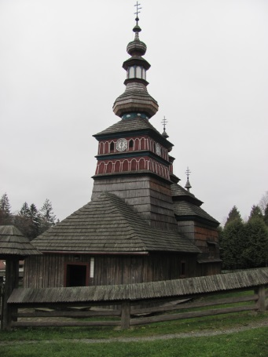
I thought about going to the Ukraine this weekend (it’s about 4 hours away) but after reading about the crime and lack of safety there, and the fact that it’s dark so early, I decided I shouldn’t go by myself. Perhaps another time…besides, Eakle (my husband) and I are headed to Budapest (Hungary), Brasov (Romania), Bucharest (Romania), Istanbul (Turkey) and Kirklareli (Turkey) over break so there will be a lot of traveling in the next couple of weeks. I will be visiting another Roma community in Kirklareli and talking with a social worker about her perception of Roma educational issues in Turkey. Upon my return to Prešov in early January I will wrap up things at the university and return to Montana mid-January.

