Your name
Grade
School
Mentor Teacher
Evidence of Professional Growth (EPG) Assignment
EDCI 519

Objectives: Through this assignment, I will be able to:
  - determine the effectiveness of my lesson plan through a comparison of pre- and post-assessments
  - reflect upon my taught lesson plan and devise strategies to improve upon it
  - visually represent the growth and development of students by way of assessment scores.

EPG Process:
Contextual Factors
- The town of Sheridan is located in North Central Wyoming on the Eastern slope of the Big Horn Mountains. The town rests in the Powder River Basin, so it is largely shielded from the stereotypical Wyoming wind. The town is 95.93% white, 0.22% Black, and 0.97% American Indian. 20.28% of the townspeople are of school age (K-12).
- Sheridan High School is located in the Northwest corner of town near an apartment building and a neighborhood of townhomes housing elderly people and young people without children. Grades 9-12 are in this school and there are approximately 985 students in the building and 131 staff members, 72 of whom are faculty. The building as designed by a prison architect and it shows. The windows are near the high ceiling, and the corridors are long and separate from each other. The 9th grade students are in a separate wing from the upperclassmen.
- Mrs. Beth Harman’s room is at the end of the science corridor. Her room consists of 6 rows of desks facing the east wall where a long lab table and white boards are situated. The North wall also has a white board containing updates, reminders, and the week’s assignments for each class. The lab section of the room is on the south side of the room. Plenty of natural light flows in through the windows. There are six lab tables in the lab and one round table in the center. The walls are lined with cupboards containing lab materials and textbooks.
- The class in question is an Earth Science class. There are 22 students in the class. 9 are girls and 13 are boys. There is one student of Pakistani descent (1st generation) and one student of Chinese descent (2nd generation). Three of the students are Apostolic Lutherans, a prominent religion in Sheridan that is known for its conservatism and prohibition of music and television for its members. This affects the teacher’s freedom to show videos, movies, or play music in the classroom.
Prior Learning
- The pre-assessment given to the students involved a lab activity. The students were given mineral samples and asked to identify the minerals in the sample box. The students had not been introduced yet to mineral identification. Any prior knowledge came from outside the classroom in the natural environment as they whiled away an afternoon at the sand dunes or on a camping trip with their grandpas who are seasoned geologists.
- Results: The graph below (Figure 1) shows that the students scored abysmally on the pre-test due to lack of prior knowledge.

Lesson Plan
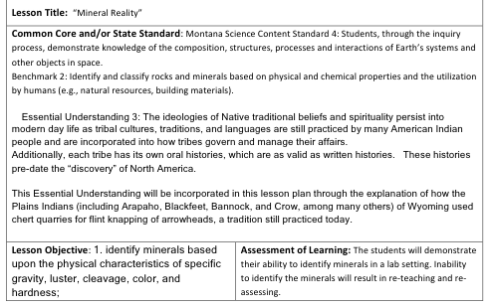
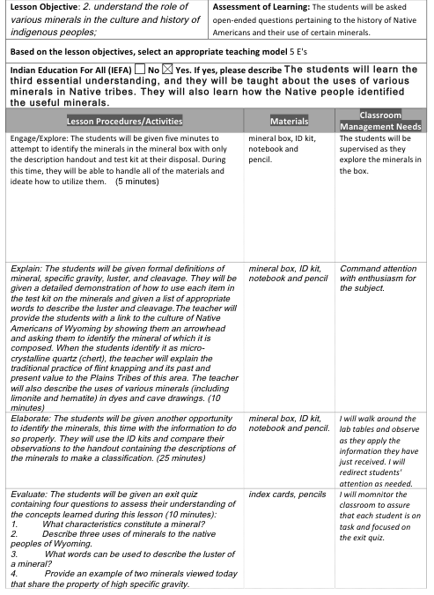
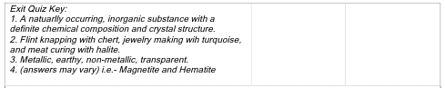

Teach Lesson

Analyze Assessment Results
- As shown in the graph, the students did not know how to identify minerals prior to instruction. The maximum number of correct answers on the pre-test was 2. This was given by students 13 and 22.
- The graph also shows the students’ post-test scores. The scores indicate that 12 out of 22 students correctly identified all of the minerals. Additionally, 6 students only misidentified one of the minerals. This means that 18 of 22 (or 82%) identified all or nearly all minerals correctly.
- Two students (4 and 11) identified 10 minerals correctly and one student (6) identified 9 correctly. Another student (student 17) was only able to correctly identify 7 minerals correctly. Student 17 was absent on the day of the lab activity and worked alone while making it up after school on a Friday. It is my belief that the student was in a hurry to leave and would have benefitted from the group work in the lab.
- These results indicate that the students who were present during the lab gained knowledge about the process of mineral identification. Furthermore, the students must have learned about the terminology related to mineral and rock identification.

Figure 1 This figure shows the difference between the pre- and post-assessment scores of the students in an Earth Science class.

Reflections on Impact of Lesson on Student Learning
- Usefulness of Data: The data used in this lesson was useful for showing me what areas the students performed well in. The graph showed me that the students who miss a lab activity need extra help to simulate the lab experience and deepen understanding.
- Effective Instruction: The instruction appears to have been effective based upon the post-test results. The instruction must have been lacking (or the engagement level was not on par) for the student who missed lab and had to make it up after school.
- Revisions and Adjustments: Before teaching this lesson again, I would be sure to encourage the students to ask one another for help before coming to the teacher. I wanted this lesson to be student-led, but they were so scared of being wrong that they continually asked me if their answers were correct before moving on. It is my desire that students know that an incorrect answer is not the end of the world, and that in the real world, they will always be able to bounce ideas off of colleagues so why not start now? In the future, I will put emphasis on the idea that wrong answers are a natural part of learning and discovery. I will also require that students ask one another for help before coming to me. Teaching each other is an excellent way to solidify concepts and gain knowledge.
- Meeting Objectives: The objectives of this lesson plan were met because the students were able to use rock and mineral terminology to identify unknown minerals in a sample box. The students also gained knowledge about Native American practices of flint napping and the importance of that cultural history.
- Assessment: Because this was a lab activity, the lab sheet and exit quiz I gave provided valuable information to me about the students’ grasp of the concept of mineral identification. If I were the teacher of this class and the person administering the unit exam, I would be sure to include an open-ended question about the importance of mineral identification to the Plains tribes of Wyoming and also include a lab practical of sorts in which the students must identify at least 5 minerals. This would allow me to assess the retention of the lesson.

Implications for Further Teaching
To expand upon this lesson, I would continue the unit into identification of sedimentary, igneous, and metamorphic rocks. The students would be able to use what they’ve learned in this lesson as a building block for identifying rocks. They could identify minerals in the rocks to determine the rock type. A unit like this would be extensive to ensure that mastery is occurring.

